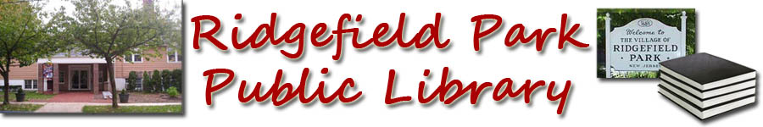
- Books Before Kindergarten
Books 401-500

401. _______________________________
402. _______________________________
403. _______________________________
404. _______________________________
405. _______________________________
406. _______________________________
407. _______________________________
408. _______________________________
409. _______________________________
410. ______________________________
411. ________________________________
412. ________________________________
413. ________________________________
414. ________________________________
415. ________________________________
416. _______________________________
417. ________________________________
418. ________________________________
419. ________________________________
420. _______________________________
421. ________________________________
422. _______________________________
423. ________________________________
424. ________________________________
425. _______________________________
426. ________________________________
427. _______________________________
428. _______________________________
429. _______________________________
430. _______________________________
431. ________________________________
432. ________________________________
433. ________________________________
434. ________________________________
435. ________________________________
436. ________________________________
437. ________________________________
438. ________________________________
439. _______________________________
440. _______________________________
441. ________________________________
442. _______________________________
443. ________________________________
444. ________________________________
445. ________________________________
446. ________________________________
447. _______________________________
448. _______________________________
449. _______________________________
450. _______________________________
451. ________________________________
452. _______________________________
453. ________________________________
454. ________________________________
455. ________________________________
456. ________________________________
457. _______________________________
458. _______________________________
459. _______________________________
460. _______________________________
461. ________________________________
462. ________________________________
463. ________________________________
464. ________________________________
465. ________________________________
466. ________________________________
467. _______________________________
468. _______________________________
469. _______________________________
470. _______________________________
471. ________________________________
472. _______________________________
473. ________________________________
474. _______________________________
475. _______________________________
476. _______________________________
477. _______________________________
478. _______________________________
479. ______________________________
480. _______________________________
481. ________________________________
482. _______________________________
483. ________________________________
484. _______________________________
485. _______________________________
486. _______________________________
487. _______________________________
488. _______________________________
489. _______________________________
490. _______________________________
491. ________________________________
492. _______________________________
493. ________________________________
494. _______________________________
495. _______________________________
496. _______________________________
497. _______________________________
498. _______________________________
499. _______________________________
500. _______________________________

.

Congratulations you have finished 500 books!

