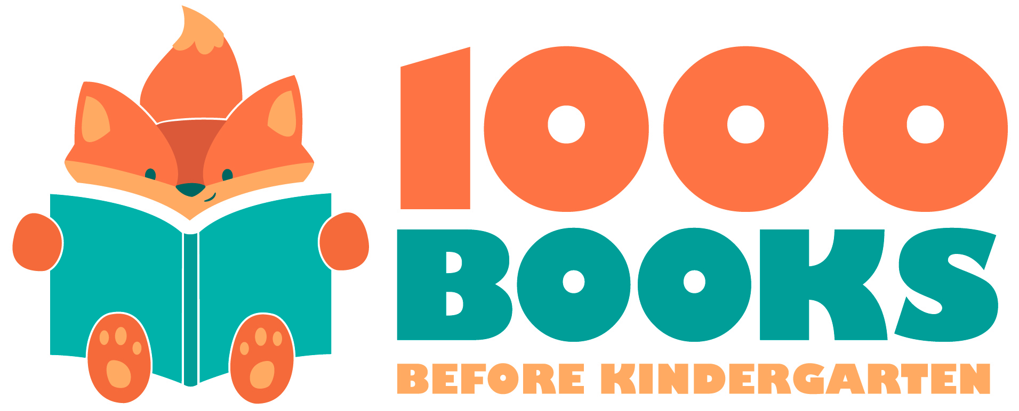
1,000 Books Before Kindergarten 101-200
Color in each square after you read a book. When you are finished, bring your completed log to the Children’s Department at the Ridgefield Park Public Library to receive your next reading log and prize!

101 | 102 | 103 | 104 | 105 | 106 | 107 | 108 | 109 | 110
111 | 112 | 113 | 114 | 115 | 116 | 117 | 118 | 119 | 120
121 | 122 | 123 | 124 | 125 | 126 | 127 | 128 | 129 | 130
131 | 132 | 133 | 134 | 135 | 136 | 137 | 138 | 139 | 140
141 | 142 | 143 | 144 | 145 | 146 | 147 | 148 | 149 | 150
151 | 152 | 153 | 154 | 155 | 156 | 157 | 158 | 159 | 160
161 | 162 | 163 | 164 | 165 | 166 | 167 | 168 | 169 | 170
171 | 172 | 173 | 174 | 175 | 176 | 177 | 178 | 179 | 180
181 | 182 | 183 | 184 | 185 | 186 | 187 | 188 | 189 | 190
191 | 192 | 193 | 194 | 195 | 196 | 197 | 198 | 199 | 200

Early Literacy Tip: As you read to your child, count objects on a page with them to introduce them to math concepts.

