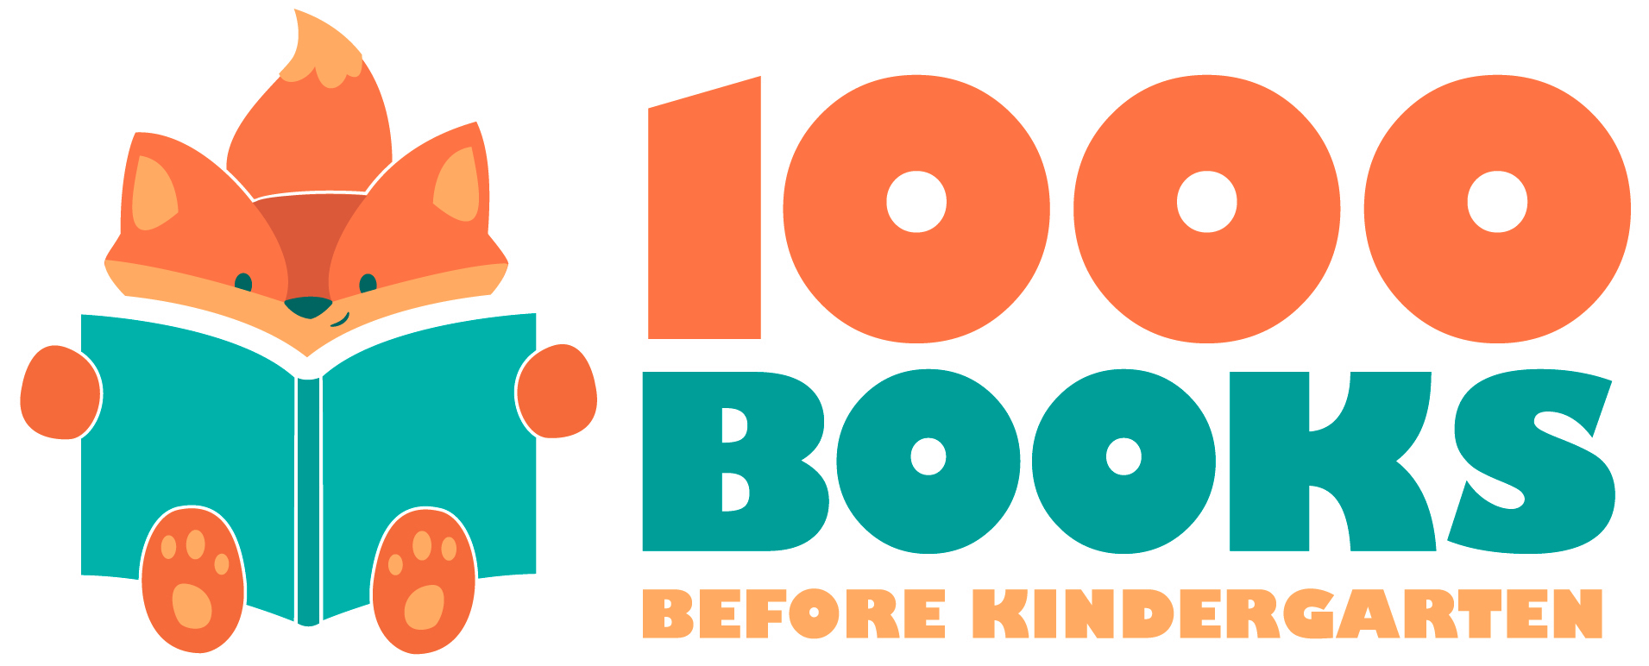
1,000 Books Before Kindergarten 401-500
Color in each square after you read a book. When you are finished, bring your completed log to the Children’s Department at the Ridgefield Park Public Library to receive your next reading log and prize!

401 | 402 | 403 | 404 | 405 | 406 | 407 | 408 | 409 | 410
411 | 412 | 413 | 414 | 415 | 416 | 417 | 418 | 419 | 420
421 | 422 | 423 | 424 | 425 | 426 | 427 | 428 | 429 | 430
431 | 432 | 433 | 434 | 435 | 436 | 437 | 438 | 439 | 440
441 | 442 | 443 | 444 | 445 | 446 | 447 | 448 | 449 | 450
451 | 452 | 453 | 454 | 455 | 456 | 457 | 458 | 459 | 460
461 | 462 | 463 | 464 | 465 | 466 | 467 | 468 | 469 | 470
471 | 472 | 473 | 474 | 475 | 476 | 477 | 478 | 479 | 480
481 | 482 | 483 | 484 | 485 | 486 | 487 | 488 | 489 | 490
491 | 492 | 493 | 494 | 495 | 496 | 497 | 498 | 499 | 500

Early Literacy Tip: Repetition is the key to learning. If your child loves a book, continue to read it to them!

