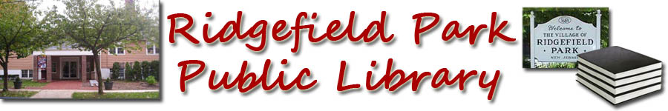 your library logo here 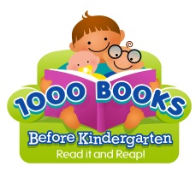
- Books Before Kindergarten
Books 101-200

101. _______________________________
102. _______________________________
103. _______________________________
104. _______________________________
105. _______________________________
106. _______________________________
107. _______________________________
108. _______________________________
109. _______________________________
110. ______________________________
111. ________________________________
112. ________________________________
113. ________________________________
114. ________________________________
115. ________________________________
116. _______________________________
117. ________________________________
118. ________________________________
119. ________________________________
120. _______________________________
121. ________________________________
122. ________________________________
123. ________________________________
124. ________________________________
125. ________________________________
126. ________________________________
127. ________________________________
128. ________________________________
129. ________________________________
130. _______________________________
131. ________________________________
132. ________________________________
133. ________________________________
134. ________________________________
135. ________________________________
136. ________________________________
137. ________________________________
138. ________________________________
139. _______________________________
140. _______________________________
141. ________________________________
142. _______________________________
143. ________________________________
144. ________________________________
145. ________________________________
146. ________________________________
147. ________________________________
148. ________________________________
149. ________________________________
150. _______________________________
151. ________________________________
152. ________________________________
153. ________________________________
154. ________________________________
155. ________________________________
156. ________________________________
157. ________________________________
158. ________________________________
159. ________________________________
160. _______________________________
161. ________________________________
162. ________________________________
163. ________________________________
164. ________________________________
165. ________________________________
166. ________________________________
167. ________________________________
168. ________________________________
169. ________________________________
170. _______________________________
171. ________________________________
172. ________________________________
173. ________________________________
174. ________________________________
175. ________________________________
176. ________________________________
177. _______________________________
178. _______________________________
179. ______________________________
180. _______________________________
181. ________________________________
182. ________________________________
183. ________________________________
184. ________________________________
185. ________________________________
186. ________________________________
187. _______________________________
188. _______________________________
189. _______________________________
190. _______________________________
191. ________________________________
192. ________________________________
193. ________________________________
194. ________________________________
195. ________________________________
196. ________________________________
197. _______________________________
198. _______________________________
199. _______________________________
200. _______________________________

.

Congratulations you have finished 200 books!

