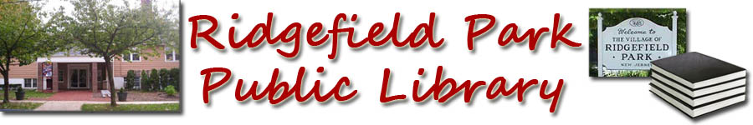
- Books Before Kindergarten
Books 601-700

601. _______________________________
602. _______________________________
603. _______________________________
604. _______________________________
605. _______________________________
606. _______________________________
607. _______________________________
608. _______________________________
609. _______________________________
610. ______________________________
611. ________________________________
612. ________________________________
613. ________________________________
614. ________________________________
615. ________________________________
616. _______________________________
617. ________________________________
618. ________________________________
619. ________________________________
620. _______________________________
621. ________________________________
622. _______________________________
623. ________________________________
624. ________________________________
625. _______________________________
626. ________________________________
627. _______________________________
628. _______________________________
629. _______________________________
630. _______________________________
631. ________________________________
632. ________________________________
633. ________________________________
634. ________________________________
635. ________________________________
636. ________________________________
637. ________________________________
638. ________________________________
639. _______________________________
640. _______________________________
641. ________________________________
642. _______________________________
643. ________________________________
644. ________________________________
645. ________________________________
646. ________________________________
647. _______________________________
648. _______________________________
649. _______________________________
650. _______________________________
651. ________________________________
652. _______________________________
653. ________________________________
654. ________________________________
655. ________________________________
656. ________________________________
657. _______________________________
658. _______________________________
659. _______________________________
660. _______________________________
661. ________________________________
662. _______________________________
663. ________________________________
664. _______________________________
665. _______________________________
666. _______________________________
667. _______________________________
668. _______________________________
669. _______________________________
670. _______________________________
671. ________________________________
672. _______________________________
673. ________________________________
674. _______________________________
675. _______________________________
676. _______________________________
677. _______________________________
678. _______________________________
679. ______________________________
680. _______________________________
681. ________________________________
682. _______________________________
683. ________________________________
684. _______________________________
685. _______________________________
686. _______________________________
687. _______________________________
688. _______________________________
689. _______________________________
690. _______________________________
691. ________________________________
692. _______________________________
693. ________________________________
694. _______________________________
695. _______________________________
696. _______________________________
697. _______________________________
698. _______________________________
699. _______________________________
700. _______________________________

.

Congratulations you have finished 700 books!

